I2C protocol

Connect multiple slaves to a single master. You can have multiple slaves and multiple masters. I2C uses only 2 wires to transfer data between nodes.

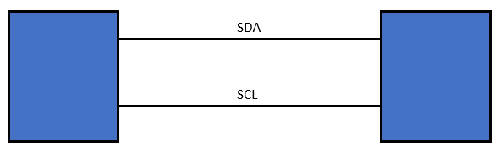

SDA = Serial Data

SCL = Serial Clock

Data is transferred bit by bit along the SDA line.

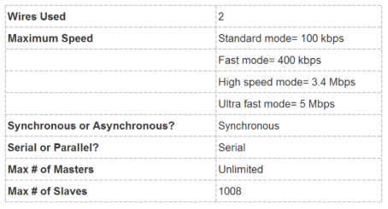

Placeholder.